Comparative study between microwave ablation versus radio frequency ablation of great saphenous vein in primary varicose veins
Mohamed Shehta Abd Elhady, MSc; El-Sayed A. Abd El-Mabood, MD; Mostafa Baioumy Abdel Wahab, MD; Mohammed A. Waly, MD;.
Vascular unit, Departments of General Surgery, Benha University, Benha, Egypt.
Abstract
Purposes: Find out advantages & Efficacy of EMA Versus RFA in treatment Of primary varicose veins.
Background: Varicose veins treatment places a considerable annoying problem on the medical system, with long waiting time for operation in the public hospital system. Both EMA and RFA allow efficient treatment of many patients on out-patient basis.
Patients and methods: This prospective randomized interventional study included 40 patients diagnosed with GSV reflux and patients were randomly allocated by using a computer generated random number table (Central Randomization System) into one of the two parallel treatment groups in a 1:1 ratio according to the intervention performed; Group I: Endovenous Microwave Ablation (EMA); (N=20 (50%)), Group II: radio frequency ablation (RFA): (N=20 (50%)).All patients underwent clinical evaluation, routine hematological tests, Venous duplex of both lower limbs. Follow-up period was for 12-months
Results: All of them passed uneventful intra-operative course without complications. Most patients needed spinal anesthesia; 17 (85%) in group (I) and 15 (75%) in group (II). Mean operative time was 76.8±4; range: 60-91minutes in group (I) and 69.1±3 range: 53-79minutes in group (II). There was no significant difference in postoperative complications during post intervention follow up for 12months between the studied groups. Also, there was no significant difference in number of patients who didn’t have any complications between the studied groups.
Conclusions: Both ablation techniques are safe and effective. However, the findings of this study suggest that the EMA procedure is a safe and effective ablation approach for patients with VVs and it leads to fewer thermal-related complications and short term recurrences.
Key words: Great Saphenous Vein Reflux, EMA, RFA, Efficacy.
Introduction:
Great saphenous vein (GSV) varicosis is a common peripheral vascular disease usually caused by incomplete venous valve closure, which results in venous blood backflow and distal veins stasis and then dilation, bulging and twisting of the GSV. ⁽¹⁾
GSV varicosis affects about a third of the adults, and mostly occurs in people engaging in sustained standing jobs, having high intensity of physical activity, or sitting for a long time with less movement. The patients may suffer from occasional discomfort, itching, pigmentation and skin ulceration, impairing their quality of life. ⁽²⁾
The traditional treatment of this condition is saphenofemoral ligation with stripping of the great saphenous vein (GSV) followed by varicose vein removal, if necessary. However, after more than 100 years of performing this procedure, today’s scientific literature shows no consensus as to the single best approach to the treatment of varicose veins. There has been a trend toward less invasive procedures to reduce the number of incisions and provide more selective ablation of varicosities. ⁽³⁾
Because of the need of less invasive treatment, endovenous thermal ablation techniques, such as radiofrequency ablation (RFA) and endovenous laser ablation (EVLA), have been developed. ⁽⁴⁾
RFA generates thermal energy by radiofrequency generator and special electrode catheter, resulting in high heating of local tissues contacting the electrode catheter to produce endothelial damage. ⁽⁵⁾
For EVLA, the laser is converted into thermal energy through the optical fibre, which causes thermal injury to the target vein endothelium and its resultant occlusion. ⁽⁶⁾ Both RFA and EVLA have shown good efficiency and high safety. ⁽⁷⁾
Endovenous microwave ablation (EMA) is a relatively novel method of thermal ablation treatment. It differs from RFA in that it does not use a thermocouple to regulate the temperature at the venous wall. ₍₈₎
This study aims to compare between microwave ablation (EMA) and radiofrequency ablation (RFA) of great saphenous vein in primary varicose veins.
Patients and Methods:
The current study was Prospective randomized interventional study and was conducted in the vascular surgery unit, Department of General surgery, Faculty of medicine, Benha University hospitals from October 2022 to October 2024 so as to allow 12 months follow-up period for last case operated on. Approval of local research ethical committee of department of surgery and Benha faculty of medicine was taken before preceding the study and obtaining written fully informed patients consent before enrollment in the study.This study included 40 patients diagnosed with primary varicose veins. This randomized clinical trial was conducted on 40 patients diagnosed with GSV reflux and patients were randomly allocated by using a computer generated random number table (Central Randomization System) into one of the two parallel treatment groups in a 1:1 ratio according to the intervention performed; Group I: Endovenous Microwave Ablation (EMA); (N=20 (50%)), Group II: radio frequency ablation (RFA): (N=20 (50%)).
Patients included in this study were Patients aged 18-80 years and Patients clinically diagnosed as primary GSV insufficiency with reflux lasting >0.5 s on Doppler ultrasonography. But patients were excluded from this study; Patients with a diameter of target lesion vein <2 mm or >15 mm; Patients with a history of surgical treatment on the target lesion; Patients with deep vein thrombosis or superficial vein thrombosis; Patients with acute systemic infectious diseases; Patients with severe liver and kidney dysfunction (alanine aminotransferase >3 times the upper limit of normal value; creatinine >225 µmol/L); Patients with known uncorrectable bleeding or severe coagulopathy; Patients with anaesthesia contraindications; Patients with poorly controlled hypertension (systolic blood pressure ≥160 mm Hg and/or diastolic blood pressure ≥100 mm Hg) and diabetes mellitus (fasting glucose ≥10.0 mmol/L); Patients with non-primary varicose veins caused by post deep vein thrombosis syndrome, Klippel-Trenaunay syndrome, arteriovenous fistula, and so on; Patients with other diseases that may cause difficulty in the trial or the evaluation, such as mental illness, AIDS, malignant tumours, liver disease, cardiac insufficiency and so on, or patients with expected life less than 1 year and Pregnant women, lactating women or women preparing to be pregnant during the trial.
All patients presenting were admitted at vascular unit, General Surgery ward for clinical evaluation, routine hematological tests, venous duplex of both lower limbs; after this, the patient was posted for intervention.
Interventions:
In both groups; Patients were operated under general, regional or local anesthesia on a morning list. Preoperative marking of the patient in the standing position with an indelible marker was important in any case in which foam injection Sclerotherapy was done. Such marking was essential because visualization of varicose tributaries may be impossible once the patient was prepared and the leg elevated. Patients were placed in supine anti-trendelenburg position in order to minimize shrinkage of the vein with the leg slightly flexed abducted and externally rotated then were shaved immediately preoperatively with a clipper and the leg was cleansed with an appropriate surgical preparation i.e. aqueous povidone iodine 10% solution and draped with the entire leg exposed from above the groin to just above the ankle.
Duplex ultrasonography was used to confirm and map all areas of reflux and to trace the path of the refluxing great saphenous trunk from the saphenofemoral junction down the leg to the lower thigh or upper part of the calf. The vein, the saphenofemoral junction, and the anticipated entry point are marked on the skin.
Then GSV was accessed utilizing direct ultrasound guidance and micropuncture technique with a 16-gauge needle introducer; If vasospasm occurred before successful cannulation, application of tourniquet proximal to the access site in conjunction with dependent positioning of the leg could be helpful or Finally direct cut-down over GSV could present itself; in these technique; lidocaine 1% was infiltrated over the site and make 1 cm small skin incision over the GSV then cannulation was proceeded under direct visualization. The ideal point of entry was caudal to most caudal point of reflux but not more than 10-15 cm below the knee (below which point saphenous nerve lies in close proximity to the vein).
Then needle puncture of the vessel was guided by duplex ultrasonography. The Seldinger technique is used to place a guidewire into the vessel, and an introducer sheath is passed over the guidewire, which is removed.
After gaining the great saphenous vein in both groups by the catheter; tumescent anesthesia was used; (200 to 500 mL) to fully surround the saphenous vein; A combination of 25-40 mL of 1-2% lidocaine with 1 ml epinephrine (1:100000), 10 mL of sodium bicarbonate, and 450 mL of cold (4c0) normal saline in the tumescent mixture, which was administered peri-venously under duplex scanning using an infusion injector of microwave device in group I and infusion pump in group II until collapse of the GSV and non-echogenic halo of fluids were observed around the main trunk of GSV. Delivery of the tumescent anesthetic was helped by tourniquet application and was applied perivenous and patient was placed in Trendlenberg's position to achieve maximum vein collapse.
The Procedure of Group I: Endovenous Microwave Ablation (EMA):
The microwave treating fiber (Microwave Intracavity Coagulation System; Shanghai Medical Electronics, Shanghai, China) was inserted into the GSV through vascular sheath 6 F or 7F and introduced until it reached the sapheno femoral junction then withdraw it about 2 cm distal to saphenofemoral junction to minimize the risk of DVT or injury to the central veins, guided by duplex and by a light that illuminated the tip of the wire. Then, GSV was ablated using pulse mode at 20-30 W. The treating wire was withdrawn at 2-4 mm/s, with the ablation time lasting 2 s (energy delivery to the GSV was estimated at around 80 J/cm); the treatment parameters was be based on a previous report. Tumescence will be used in all patients with 0.9% saline containing 20 mL 2% lidocaine with 1: 200,000 adrenaline and 20 mL 0.5% levobupivacaine in 1 L 0.9% saline. This fiber induces vein ablation 3 cm each time. Catheter shaft markings every 1cm, Ensures 2cm overlap between treated segments. 6-7F Catheter has its own injector for tumescence. The same as LASER; it needs amount of blood around the fiber to induce got steam bubbles but Heat water (80-100Co) in cells so denature proteins; it doesn't emit light so no need protective eyewear & the tip of microwave fiber (1cm) is PTFE to be smooth and not to be sticky with the vein
The Procedure of Group II: radio frequency ablation (RFA):
Procedure Setup; includes Movable Operation Table (Anti Trendelenburg/ Trendelenburg), Sheath 7F., Puncture needle 18G, Yellow Spinal needle, Tumescent Ingredient (Saline, Lidocaine, & Sodium Bicarbonate) and Duplex Device, Tumescent Injector, ClosureFast System & Bandage.
System includes ClosureFAST Catheter Specifications; 7F Catheter (7F heating coil; 4F catheter shaft), 7 cm length heating coil, Available in 60 or 100 cm, Catheter shaft markings every 6.5 cm, Ensures ½ cm overlap between treated segments, Catheter lumen accepts 0.025” guide wire, Segmental Ablation Technology, 7 cm vein segments treated at once, No energy delivery during repositioning and energy delivery does not vary by pullback speed.
A 0.025-inch guide wire was inserted into GSV and the needle was removed. Next, a 7F × 10-cm sheath was advanced over the wire and the VNUS catheter was inserted and advanced over the wire to the predetermined point. Optimal positioning of the catheter tip was 2 cm peripheral to the SFJ that was done under U/S guidance to minimize the risk of DVT or injury to central veins.
Positioning of the catheter tip was reconfirmed with ultrasound before treatment is commenced; after that the generator was turned on. Then the energy generator was started, radiofrequency treatment was performed for 20 s/time, the temperature of the great saphenous vein was raised to 120°C, and the treatment was repeated up to three cycles in the initial segment but any segment should not undergo more than three treatment cycles; there was 0.5-cm overlap of each pair of segments and the pulled back was continuous until the desired vessel length was treated. When the final segment was treated, pulling of heating element of the catheter was avoided into the sheath because it might melt the sheath. The generator was turned off and sheath and closure catheter were then removed and hemostasis was obtained with manual compression over the access site. The radiofrequency ablation closure catheter and short sheath are removed after the injury and compression bandaged.
In both groups; after the fiber or catheter has been withdrawn to the venotomy site, the saphenous vein is again evaluated with ultrasound. Typically, one identifies vessel wall thickening, concentric narrowing, and absence of flow, indicating successful endovenous saphenous vein obliteration procedure. Common femoral vein is also evaluated for compressibility and absence of thrombus.
Further treatment by U/S guided sclerotherapy for the residual tributaries was performed immediately at the end of the RFA procedure; The sclerosant used in this study was Aethoxysklerol 2%. The areas of concern were disinfected with a Povidone iodine solution 10%, the sclerosing agent solution was prepared for foam sclerotherapy, it was aspirated in a 10-mL syringe and connected to a 3-way cannula with a 10-mL syringe containing 7 mL of air; the syringes were rapidly depressed sequentially to create the foam (1:4) sclerosant to air volume ratio.
A vein light was used to identify the reticular vein that was less than 5 mm. and a 26-G needle was placed into the vein with return of blood confirmed. The foam was injected through the needle while observing the foam displace the blood from the vein; the needle was removed at the end of the injection, in some cases injection of the foam through multiple cannula inserted in the dilated tributaries was done. After all injections were completed, pressure dressings were placed on the veins treated and simultaneously, the leg was elevated to achieve 90oof hip flexion. Thigh and knee were wrapped with an elastic compression bandage for 5 days continuously, taking it off only to shower; then thigh high class II graduated compression stocking was applied for 2 weeks to decrease post procedure bruising.
- Post-intervention follow up:
Clinical evaluation was performed on all subjects at 1 week, 3, 6 and 12 months. Patients were asked about symptomatic relief at follow-up visits, particularly improvement or resolution of lower-extremity pain associated with venous insufficiency. Improvement in the appearance of the leg including reduction in visible varicosities, swelling, pigmentation or other skin changes secondary to CVI were assessed by the patient and with direct comparison with pre-treatment photographs obtained from all subjects undergoing treatment. Patients were evaluated for possible adverse reactions caused by interventions at each follow-up visit. Minor complications were defined as those that had no significant clinical sequelae such as bruising. Major complications were defined as those necessitating an increased level of care, surgery or hospitalization.
Statistical analysis: The collected data will be presented in tables and suitable graphs and analyzed by (SPSS). Quantitative variables will be expressed as mean ± SD, and range. Qualitative variables as frequency and percentage .the level of significance will be p<0.05.
These all data were shown in the following pictures: Fig. (1,2)
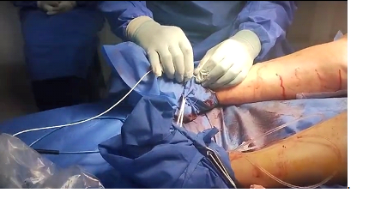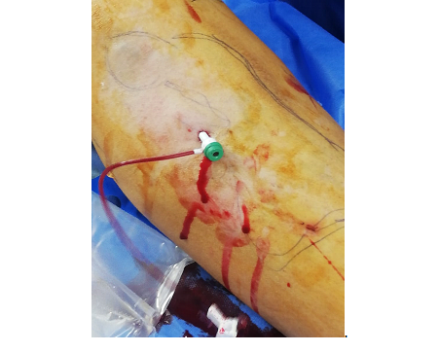
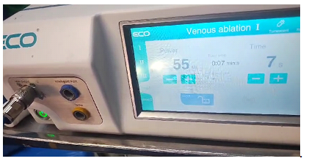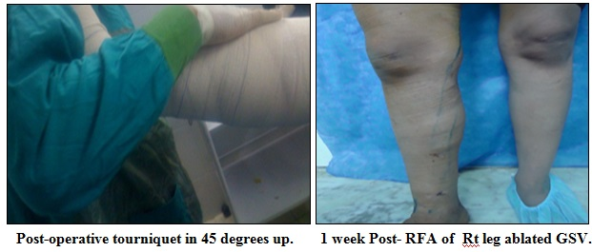
Figure (1): Fiber withdrawal while generator off and on using pedal maneuver.
- Steps of the procedure of Group I: Endovenous Microwave Ablation (EMA).
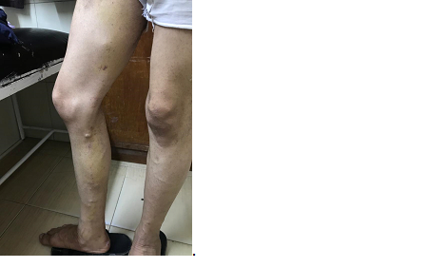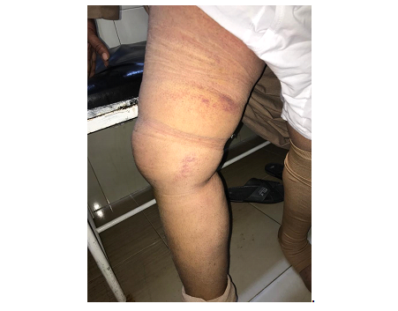
Before. After 2 wks.
- A case of Group I: Endovenous Microwave Ablation (EMA).
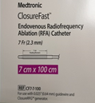
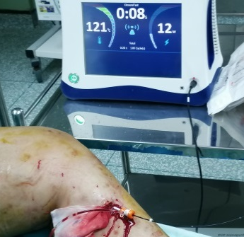
Figure (2): Probe + finger compression & Generator off and on.
- Steps of the Procedure of Group II: radio frequency ablation (RFA).
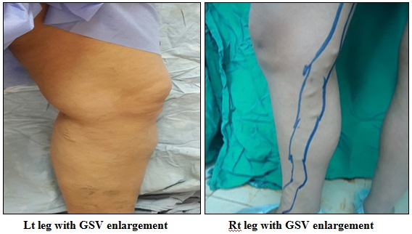
A case of Group II: radio frequency ablation (RFA).
Results:
This is a prospective randomized clinical trial that was conducted on 40 patients diagnosed with GSV reflux in Department of surgery - vascular unit of Benha University Hospitals to compare between microwave ablation and radiofrequency ablation. Patients were divided into two groups: Group I: Endovenous Microwave Ablation (EMA); (N=20 (50%)), Group II: radio frequency ablation (RFA): (N=20 (50%)). The age of studied cases ranged from 24 to 59years, mean age in group (I) was 33.7ys and in the group (II) was 35.4ys. There were 12 female patients and 8 male patients in group (I) where in group (II) 13 female and 7 male patients. There was no statistical difference between both groups in demographic data; Tab. (1), Graph. (1)
Tab. (1): Patients' demographic data:
Variables |  | Group I  N=20 (50%) | Group II  N=20 (50%) | P-Value
Age (years) |  | 33.7±6 | 35.4±3.1 | 0.44 Non Significant (NS)
Gender | Male ♂ | 8 (40.%) | 7 (35%) | 0.23 NS
Gender | Female ♀ | 12 (60%) | 13 (65%) | 0.23 NS
Data are presented as numbers & mean ± SD; percentages & ranges are in parenthesis.

Graph. (1): Patients' demographic data.
As regard CEAP and VCSS; there was no significant difference in clinical class and VCSS between the studied groups. Tab. (2), Graph. (2).
Tab. (2): Clinical class (CEAP) and VCSS in both groups:
 |  | Group I | Group II | P value
Clinical class | C2 | 2 (10%) | 1 (5%) | 0.859 NS
Clinical class | C3 | 12 (60%) | 13 (65%) | 0.859 NS
Clinical class | C4 | 7 (35%) | 6 (30%) | 0.859 NS
Clinical class | C5 | 1 (5%) | 2 (10%) | 0.859 NS
VCSS | Mean ± SD | 6.9 ± 1.93 | 7.1 ± 2.1 | 0.289 NS
VCSS | Range | 5 - 14 | 5 - 11 | 0.289 NS
CEAP: Clinical, Etiology, Anatomy, Pathophysiology class.
VCSS: Venous Clinical Severity Score.
Data are presented as numbers & mean ± SD; percentages & ranges are in parenthesis

Graph. (2): Baseline clinical class (CEAP) and VCSS in both groups.
All of them passed uneventful intra-operative course without complications. Most patients needed spinal anesthesia; 17 (85%) in group (I) and 15 (75%) in group (II). Mean operative time was 76.8±4; range: 60-91minutes in group (I) and 69.1±3 range: 53-79minutes in group (II). Mean intra-operative blood loss was 56±5.5; range: 50-60ml in group (I) and 47.2±5.1 range: 40-50ml in group (II). There was no significant difference in procedure data (length of vein treated and duration of procedure) between the studied groups. Tab. (3), Graph. (3).
Tab. (3): Operative data:
Variables |  | Group I | Group II | t | P-Value
Tumescent and spinal |  | 17 (85%) | 15 (75%) |  | 0.723 NS
Tumescent and general |  | 2 (10%) | 3 (15%) |  | 0.723 NS
Tumescent alone |  | 1 (5%) | 2 (10%) |  | 0.723 NS
Operative time * (minutes) | Mean ± SD | 76.8±4 | 69.1±3 | 3.5 | 0.11 NS
Operative time * (minutes) | Range | 60-91 | 53-79 | 3.5 | 0.11 NS
Intra-operative blood loss (ml) | Mean ± SD | 56±5.5 | 47.2±5.1 | 7.1 | 0.01 S
Intra-operative blood loss (ml) | Range | 50-60 | 40-50 | 7.1 | 0.01 S
Length of vein treated (cm) | Mean ± SD | 40.6 ± 13.9 | 36.3 ± 14.8 |  | 0.254 NS
Length of vein treated (cm) | Range | 15 - 61 | 11 - 53 |  | 0.254 NS
Intraoperative  VAS score ** | Mean ± SD | 2.9 ± 1 | 4.1 ± 1.5 | 9 | 0.01 S
Intraoperative  VAS score ** | Range | 2 - 5 | 2 - 6 | 9 | 0.01 S
*Operative time: defined as time between initiations of the ablation after the device is inserted into the vein and the time after the ablation is completed.
**VAS: Visual Analogue Score.
Data are presented as numbers & mean ± SD; ranges are in parenthesis and statistically significant difference by using unpaired t-test.

Graph. (3): Operative data; operative time and blood loss.
Upon review of the results in this study post-operative pain was assisted for both groups by using the (0-10) Numeric Pain Rating Scale and relating doses of analgesic drugs; significant difference between both groups was noticed; Group (I) average doses was (11.3±0.9) and pain rate was (6.3±1.99) Vs (7.4±2.3) for group (II) and pain rate was (4.05±1.06); t =10.9 & t =4.5 P- value: 0.001; EMA Patients had moderate to severe pain and received more analgesic drugs than RRA patients who had mild to moderate pain. Tab. (4), Graph. (4).
Tab. (4): Post-operative pain assessment using "0-10 Numeric Pain Rate":
Variables | Group I | Group II | t | P-Value
Doses of pain analgesic  (mean ±SD) | 11.3±0.9 | 7.4±2.3 | 7.3 | 0.01 S
PO Numeric Pain Rate  (mean ±SD) | 6.3±1.99 | 4.05±1.06 | 5.4 | 0.01 S
Data are presented as numbers & mean ± SD; ranges are in parenthesis and statistically significant difference by using unpaired t-test.

Graph. (4): Post-operative pain assessment using "0-10 Numeric Pain Rate".
Patients in group (I) were discharged 1-3 days Post-Operative (PO); But in group (II) were discharged 1-2 days PO. There was no significant difference in post-operative outcomes (recovery time, return to work, and failure of procedure) between the studied groups. Failed case was due to tortuosity.Tab. (5), Graph. (5).
Tab. (5): Post-Operative (PO) data:
Variables |  | Group I | Group II | P-Value
Duration of PO hospital stay (days) | Mean ± SD | 2.1±0.5 | 1.9±0.4 | 0.01 S
Duration of PO hospital stay (days) | Range | 1-3 | 1-2 | 0.01 S
Recovery time (days) | Median (IQR) | 2 (1 – 3) | 2 (1 – 2) | 0.068
Recovery time (days) | Range | 1 – 7 | 1 – 6 | 0.068
Return to work (days) | Median (IQR) | 2 (1 – 4) | 3 (1 – 5) | 0.411
Return to work (days) | Range | 0 – 12 | 0 – 13 | 0.411
Failure of procedure | Failure | 1 (5%) | 0 | 1.000
Data are presented as numbers & mean ± SD; ranges are in parenthesis and statistically.

Graph. (5): Post-Operative (PO) data.
There was no significant difference in postoperative complications after one week between the studied groups. Also, there was no significant difference in number of patients who didn’t have any complications between the studied groups. Tab. (6), Graph. (6).
Tab. (6): Postoperative complications after 1 week in both groups:
 | Group I | Group II | P value
Pigmentation | 5 (25%) | 3 (15%) | 0.532
Paresthesia | 3 (15%) | 5 (25%) | 0.532
Burn (Ulcers) | 0 (0.00%) | 1 (5%) | 0.567
Superficial thrombophlebitis | 4 (20%) | 3 (15%) | 0.748
Hematoma | 3 (15%) | 4 (20%) | 0.748
Erythema | 1 (5%) | 1 (15%) | 1.000
No complications | 13 (65%) | 15 (75%) | 0.398
Data are presented as numbers & mean ± SD; ranges are in parenthesis and statistically.

Graph. (6): Postoperative complications after 1 week both groups.
After 6-12 months; there was no significant difference in postoperative complications (Pigmentation, Paresthesia, and recurrence) between the studied groups. Also, there was no significant difference in number of patients who didn’t have any complications between the studied groups. Tab. (7), Graph. (7).
Tab. (7): Postoperative complications after 6-12 months in both groups:
 | Group I | Group II | P value
Pigmentation | 1 (5%) | 0 (0.00%) | 0.492
Paresthesia | 1 (5%) | 1 (5%) | 1.000
Recurrence | 0 (0.00%) | 1 (5%) | 0.237
No complications | 18 (90%) | 19 (95%) | 1.000
Data are presented as numbers & mean ± SD; ranges are in parenthesis and statistically.

Graph. (7): Postoperative complications after 6-12 months in both groups.
Severity and QoL were evaluated using the VCSS system with no statistically significant variations observed at baseline between the two groups. Postoperatively, both groups exhibited a reduction in the VCSSs except for the VCSSs at 6 months, no statistically significant variations were found between the two groups at any other point. In follow up, there was no significant difference in VCSS and patient satisfaction between the studied groups. Tab. (8), Graph. (8).
Tab. (8): Venous clinical severity score (VCSS) for both groups:
 | Group I | Group II | P value
Baseline | 6 (4-7) | 6 (4-8.5) | 0.592
1 Month | 5 (4-7) | 5 (3-7) | 0.271
3 Months | 3 (2-4.5) | 3 (2-4) | 0.221
6 Months | 2 (1-3) | 1 (1-2) | 0.029
12 Months | 1 (0-2) | 1 (40-1) | 0.124
Data are presented as numbers & mean ± SD; ranges are in parenthesis and statistically.
Graph. (8): Venous clinical severity score (VCSS) for both groups.
Discussion:
In Great saphenous vein (GSV) reflux The patients may complain discomfort, itching, color change and ulceration, interfering with quality of life. The common traditional surgical treatment for GSV reflux is high ligation and stripping (HLS), but it causes high postoperative apparent recurrence, long time recovery and bad wound scar. ⁽⁹⁻¹¹⁾
Because of the need of less invasive and cosmetic treatment, endovenous thermal ablation interventions, such as Radiofrequency ablation (RFA), Endovenous microwave ablation (EMA) and Endovenous laser ablation (EVLA), have been developed. RFA generates thermal energy by generator and special electrode, resulting in extensive heating of surrounding tissues contacting the electrode to produce endothelial damage. ⁽¹²⁻¹⁵⁾
The current study is a prospective randomized clinical trial that was conducted on 40 patients diagnosed with GSV reflux to compare between microwave ablation and radiofrequency ablation. Patients were divided into two groups: Group I: Endovenous Microwave Ablation (EMA); (N=20 (50%)), Group II: radio frequency ablation (RFA): (N=20 (50%)). The age of studied cases ranged from 24 to 59years, mean age in group (I) was 33.7ys and in the group (II) was 35.4ys. There were 12 female patients and 8 male patients in group (I) where in group (II) 13 female and 7 male patients. There was no statistical difference between both groups in demographic data.
This agreed with Zhao et al.; who explored the clinical results of EMA and radiofrequency ablation (RFA) in treating lower limb GSV reflux. They reported no statistically significant variations were observed in the baseline and demographic features across the two groups (P > .05). ⁽¹⁶⁻¹⁸⁾
In this study; tumescent local anesthetic solution was used in all cases (100%) beside general or spinal anesthesia; this technique provided excellent anesthesia. In addition, vasoconstriction from epinephrine and direct compressive effects of the instilled volume resulted in rapid hemostasis, a marked reduction in postoperative ecchymosis and pain and allowed separation of the superficial aspect of the GSV by at least 1.0 cm deep to the skin surface along its entire length to reduce the likelihood of skin burns and collapse of GSV to improve the transfer of thermal energy to the vessel wall. The ability to perform the procedure under tumescent local anesthesia allows for an immediate return to daily activities with optimal medical and cosmetic results, as well as high patient satisfaction. ⁽¹⁹⁻²²⁾
Our results revealed that, there was no significant difference in clinical class (CEAP classification) and VCSS between the studied groups, C3 and C4 were the most predominant in our patients. These results were near similar to Zhao et al.; who mentioned that CEAP classification and other details were similar between the two groups. ⁽¹⁶⁻¹⁸⁾
In the present study, the postoperative VAS scores for the EMA group were higher than those for the RFA group. Also, more pigmentation was present in the EMA group, which might have resulted in longer hospital stays and lower CIVIQ scores during the follow up period. However, a standardized dosage regimen has not yet been determined for the EMA system, with no cases of skin burn in the EMA group. In addition to postoperative pain, the thermal ablation techniques used to treat LLVVs often lead to heat associated adverse effects, including nerve injury, skin burns, and induration. The findings of the present investigation indicate that the EMA technique has a low occurrence of induration, ecchymosis, and paresthesia, comparable to the incidence with the RFA technique. ⁽²³⁻²⁶⁾
There was no significant difference in postoperative complications during post intervention follow up for 12months between the studied groups. Also, there was no significant difference in number of patients who didn’t have any complications between the studied groups. But there was more pigmentation and pain in EMA group (I). These results were near similar to Zhao et al. The differences in pigmentation after the procedure and the experience of postoperative pain related to the procedure might correlate with the mechanisms of the devices. ⁽¹⁶⁻¹⁸⁾
Conclusions: Both ablation techniques are safe and effective. However, the findings of this study suggest that the EMA procedure is a safe and effective ablation approach for patients with VVs and it leads to fewer thermal-related complications and short term recurrences.

References:
1-Tauraginskii R., Lurie F., Agalarov R., Simakov S. and Borsuk D. (2022): Blood flow from competent tributaries is likely contributor to distally increasing reflux volume in incompetent great saphenous vein. J. Vasc. Surg. Venous Lymphat Disord.; 10: 6974.
2-Carroll C., Hummel S., Leaviss J., Ren S., Stevens J., Everson-Hock E. and et al. (2013): Clinical effectiveness and cost-effectiveness of minimally invasive techniques to manage varicose veins: a systematic review and economic evaluation. Health Technol Assess;17:i–xvi.
3-Castro-Ferreira R., Quelhas M., Freitas A., Vidoedo J., Silva E., Marinho A. and et al. (2019): Vascular training does matter in the outcomes of saphenous high ligation and stripping. J Vasc Surg Venous Lymphat Disord;7:732-8.
4-Healy D.A., Kimura S.S., Power D.A., Elhaj A.Q., Abdeldaim Y.L., Cross K.S. and et al. (2018): A systematic review and meta-analysis of thrombotic events following endovenous thermal ablation of the great saphenous vein. Eur J Vasc Endovasc Surg;56:410–24.
5-Bademci M.Ş., Kocaaslan C.D., Aldag M.W., Yalvaç E.D., Oztekin A.K., Bulut N.J. and et al. (2019): Single-center retrospective review of early outcomes of radiofrequency ablation versus cyanoacrylate ablation of isolated great saphenous vein insufficiency. J. Vasc. Surg. Venous Lymphat. Disord.;7:480-5.
6-Attaran R.R.(2018): Latest innovations in the treatment of venous disease. J Clin Med;7:77.
7-Li Yongjun Q., Wu W., Li Younan L., Li J. and Sun M. Protocol (2022): Efficacy and safety of endovenous microwave ablation versus laser ablation for great saphenous vein varicosis: study protocol for a multicentre, randomised controlled non-inferiority trial. BMJ Open;12.
8-Epstein D., Bootun R., Diop M., Ortega-Ortega M., Lane T. and Davies A. (2021): Cost-Effectiveness analysis of current varicose veins treatments. J Vasc. Surg. Venous Lymphat. Disord. Aug.; 21(8): 911-920.
9-Carroll C., Hummel S. and Leaviss J. (2013): Clinical effectiveness and cost effectiveness of minimally invasive techniques to manage varicose
veins: a systematic review and economic evaluation. Health Technol.
Assess; 17:1-141.
10-Castro-Ferreira R., Quelhas M. and Freitas A. (2019): Vascular training does matter in the outcomes of saphenous high ligation and stripping. J. Vasc. Surg. Venous Lymphat. Disord.; 7: 732-8.
11-Healy D., Kimura S. and Power D. (2018): A systematic review and
meta-analysis of thrombotic events following endovenous thermal
ablation of the great saphenous vein. Eur. J. Vasc. Endovasc. Surg.; 56: 410-24.
12-Bademci M., Kocaaslan C. and Aldag M. (2019): Single-Center
retrospective review of early outcomes of radiofrequency ablation
versus cyanoacrylate ablation of isolated great saphenous vein
insufficiency. J. Vasc. Surg. Venous Lymphat. Disord.; 7: 480-5.
13-Subwongcharoen S., Praditphol N. and Chitwiset S. (2009): Endovenous microwave ablation of varicose veins: in vitro, live swine model,
and clinical study. Surg. Laparosc. Endosc. Percutan. Tech.; 19: 170-4.
14-Mao J., Zhang C. and Wang Z. (2012): A retrospective study comparing
endovenous laser ablation and microwave ablation for great saphenous varicose veins. Eur. Rev. Med. Pharmacol. Sci; 16: 873-7.
15-Yang L., Wang X. and Wei Z. (2020): The clinical outcomes of endovenous microwave and laser ablation for varicose veins: a prospective study. Surgery; 168: 909-14.
16-Zhao M., Hui Guo M., Yongyu Zhang Z., Xiaojun H., Jia-nan H., Dashuai Wang W., Weile Huang H., Hairun G. and Peng-fei P. (2024): Comparison of endovenous microwave ablation versus radiofrequency ablation for lower limb varicose veins in J. Vasc. Surg. Venous Lymphat. Disord.; 12:101662.
17-Halil B., Cemalettin A., Yasin A., Bekir I., Hasan E., Cemil G. and Mehmet B. (2012): Endovenous laser ablation versus high ligation and stripping (HL/S): two years follow up. Eastern Journal of Medicine 17:83-87.
18-Campbell, W.B., Vijay Kumar A.S., Collin T.W., Allington K.L. and Michaels J.A. (2003): The outcome of varicose vein surgery at 10 years: clinical findings, symptoms and patient satisfaction. Ann R. Coll. Surg. Engl.; 85: 52-57.
19-Sadek M. and Kabnick L.S. (2018): Varicose Veins, Endovenous Ablation and Sclerotherapy; Rutherford's vascular surgery and endovascular therapy 9th by Anton N.S. and Bruce A.P.; Printed in China;; 2 (155): 2039-5
20-Fedor Lurie F. and Puggioni A. (2018): Chronic Venous Insufficiency, Treatment of perforator Vein Incompetence; Rutherford's vascular surgery and endovascular therapy 9th by Anton N.S. and Bruce A.P.; Printed in China;; 2 (158): 6755-1.
21- Ricci S. (2005): Ambulatory Phlebectomy. 2nd ed. Taylor & Francis: Boca Raton, Fl; 5: 114-120.
22-Luebke T. (2008): Meta-analysis of transilluminated powered phlebectomy for superficial varicosities. J. Cardiovasc. Surg. (Torino); 49: 757-764.
23-Liang P., Dong B. and Yu X. (2006): Computer-aided dynamic simulation of microwave-induced thermal distribution in coagulation of liver cancer. IEEE Trans Biomed Eng.; 48: 821-9.
24-Yang L., Wang X., Su W., Zhang Y. and Wang Y. (2013): Randomized clinical trial of endovenous microwave ablation combined with high ligation versus conventional surgery for varicose veins. Eur. J. Vasc. Endovasc. Surg.; 46: 473-9.
25-Yang L., Wang X., Wei Z., Zhu C., Liu J. and Han Y. (2020): The clinical outcomes of endovenous microwave and laser ablation for varicose veins: a prospective study. Surgery; 168: 909-14.
26-Li Y., Wu W., Li Y., Li J. and Sun M. (2022): Efficacy and safety of endovenous microwave ablation versus laser ablation for great saphenous vein varicosis: study protocol for a multicentre, randomised controlled
non-inferiority trial. BMJ Open; 12: e059213.

